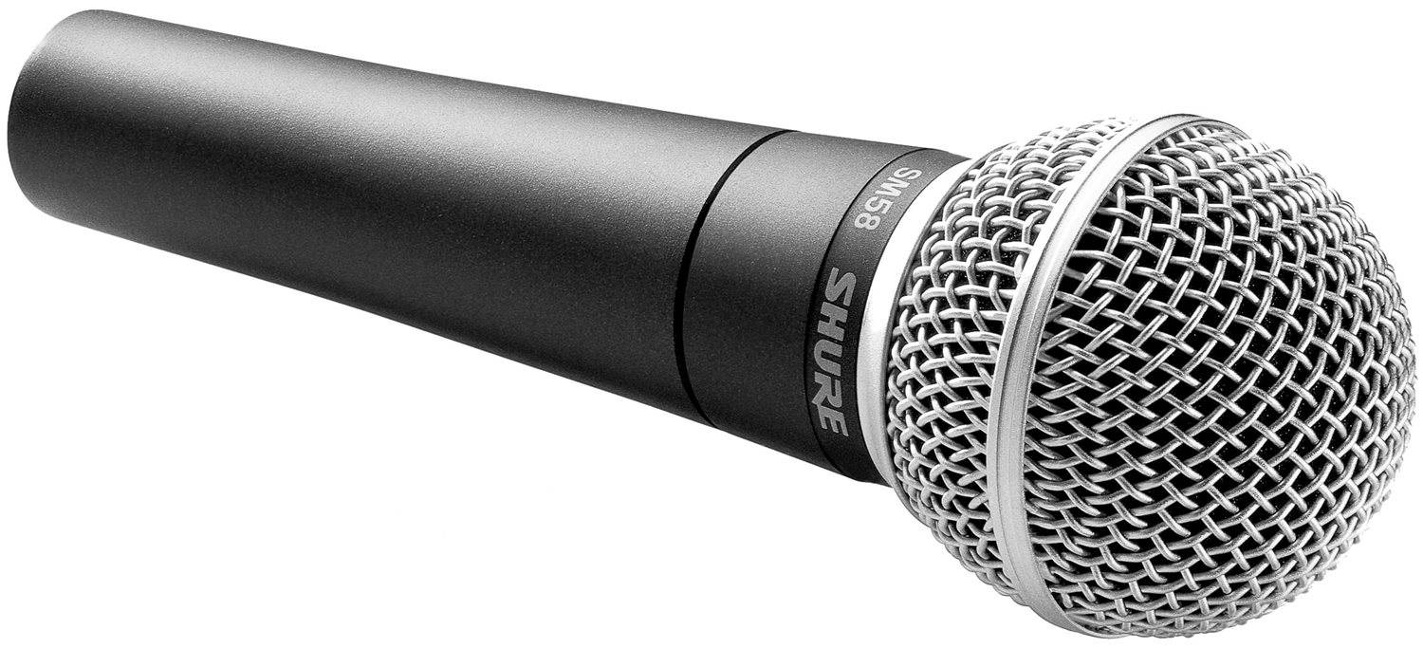
Distinguished Communications®

Presentation & Media Skills Pitching Leadership Coaching Facilitation

Sales Pitches, Bids and RFPs
When two companies are essentially equal in capabilities, the presentation can tip the scales.
If you want to put forth your best to win the business, we will get your team and your materials ready.

Presentation Boot Camp
This is an opportunity for your staff to advance their presentation skills by leaps and bounds in just 2-3 days. Students gain tips and tricks to make their presentations more impactful immediately and have several opportunities to practice speeches in front of the group and the coach. Group and private coaching are included in this workshop. The group experience prepares colleagues within the company to hold each other accountable for the skills they learned and ensure that they are used after the class. Private sessions available for executives.

Media & Crisis Communications Training
Anyone with a cellphone is a reporter today. Are you ready for every tweet or video posted about the company? We will work with you to prepare for and rehearse various scenarios to ensure that your organization is shown in the best light with the media. Our program is customized to the needs of your team and to the roles of the individual participants. And if your crisis communications plan is out of date, let us assist you in getting it and your team ready to act.

Private Coaching: Presentation Polish, Interviewing, Media Training, Leadership and More
Some schedules don’t lend themselves to group training. Private coaching is often a better fit. Individual clients average about 3-5 sessions of about 90 minutes to polish their skills.

Writing Skills
Oral communication skills don’t always translate to paper. Let us help your team become effective writers as well as impactful presenters. Private and group workshops are available.

Corporate Events
With so much “noise” coming at clients and employees every minute, via email, texts, social media, videos, etc., holding an audience’s attention can be enormously challenging. Our workshops show attendees how to break through that noise and make an impact. 1-hour, ½day and full-day sessions are available for groups interested in learning about presentation skills, interoffice communication, female communication and other topical subjects. And if you need an emcee for your awards ceremony or annual dinner, we’ll ensure the event is a memorable one – full of energy and fun.

Group Facilitation
Consensus can be difficult to build and navigating a complex group dynamic can be tricky, especially if leadership is perceived to not be neutral. Our independent, third-party professional facilitators can lead a group through a productive discussion to reach amiable outcomes.

Let’s Talk About It!

